|  |  |  |  |
| --- | --- | --- | --- |
| **Instructor** |  | **Due Date** |  |

**Review of HTML Web Page Design ( 100 points )**

**Project One Constructing a Basic Web Page**

**Objective** To build a Web page using HTML tags.

***PROJECT DESCRIPTION***

This project reviews the basics of Web page design using basic HTML tags.

***Information about This Project***

Some basic HTML tags and their functions are summarized below.

|  |  |  |
| --- | --- | --- |
| HTML **Tag** | type | **Purpose** |
| **<html>** | paired | opens the page code and encloses other HTML tags |
| **<head>** | paired | contains the page title and sometimes **<script>** tags |
| **<title>** | paired | encloses the Web page title |
| **<body>** | paired | encloses other HTML tags in the body of the Web page |
| **<h1>** | paired | the largest heading ( **<h6>** is the smallest heading ) |
| **<br />** | non - paired | creates a line break |
| **<hr />** | non - paired | creates a horizontal rule |
| **<p>** | paired | creates a paragraph |

***Steps To Complete This Project***

**STEP 1**  **Open MS Notepad on Your Computer**

Open the Notepad text editor by using these typical directives: click the **Desktop** Start button, point to All Programs , migrate to Accessories and point to and click Notepad .

Notepad opens and creates an untitled text file. Save the text file as a Web page file by clicking File on the Notepad menu and selecting Save As … . When the **Save File As** dialog box opens, click the Up One Level icon repeatedly until you reach the **Desktop**, then click the Create New Folder icon and make a new folder named **WebPages**. Open the new folder and save the text file as **Page1.htm** to the new folder on your **Desktop**. Note: to avoid having Notepad automatically adding a **.txt** extension to your file, type double quotes around your filename, " " , such that it will be saved only with your desired **.html** extension.

Click Save to close the **Save File As** dialog box.

**STEP 2**  **Design the Required Web Page**

With your HTML page open in Notepad, write the typical skeletal code of a standard Web page. This code is follows on the next page.

**Project One**

**Figure 1 HTML Source Code in Notepad**

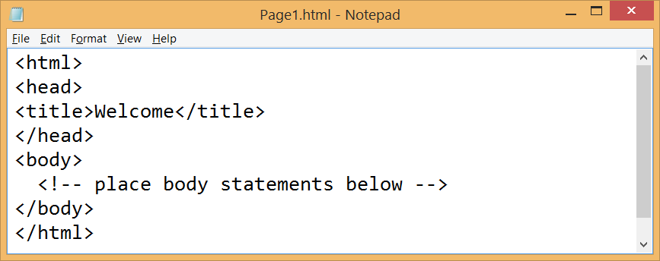

After you complete your Web page code by typing the closing **</html>** tag, save your completed Web page.

**STEP 3 Preview Your Web Page**

Preview your Web page to ensure that your HTML source code correctly displays the page. To do this, leave Notepad open and navigate to your computer’s **Desktop**. Locate the Web page entitled **Page1.html** within the **WebPages** folder on the **Desktop** and double - click the file to view it in your Web browser.

Your Web page now appears within Internet Explorer, as shown below.

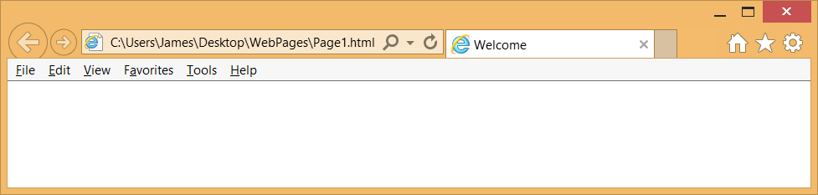

View the page. Notice the body of the Web document is empty but the word Welcome, as your page title, appears in the Internet Explorer Title bar.

Leave Internet Explorer open and return to Notepad.

**STEP 4 Add a Background Color to Your Web Page**

Once you have verified that your Web page is displayed properly within your Web browser, return to Notepad and modify your Web page.

In Notepad, locate the following HTML tag:

**<body>**

Modify the tag such that it appears as follows.

**<body style = "background-color:blue; color:white">**

After you complete the **<body>** tag, save your Web page in Notepad.

**Project One**

**STEP 5 Refresh the Page in the Web Browser**

Leave Notepad open and return to your page in Internet Explorer and press

. F5 to refresh the page in the browser.

Your page now has a blue body, as shown in the screen snapshot given below.

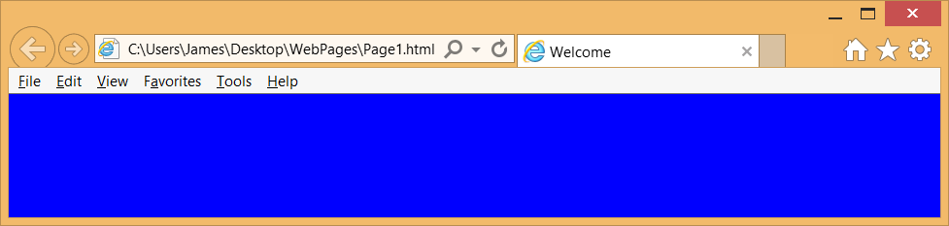

**STEP 6 Add Text to the Body**

Once you have verified that your Web page is displayed properly within your Web browser, return to Notepad and modify your Web page.

In Notepad, locate the following HTML statement:

**<!-- place body statements here -->**

Highlight this statement with your mouse and type over the statement using the following code:

**<h1>this is the largest heading style</h1>**

**<h3>this is a smaller heading style</h3>**

After you type the above statements, save your Web page in Notepad, leave Notepad open and return to your page in Internet Explorer and press F5 to refresh the page in the browser.

Your page now has a blue body with white colored text, as shown in the screen snapshot given below.

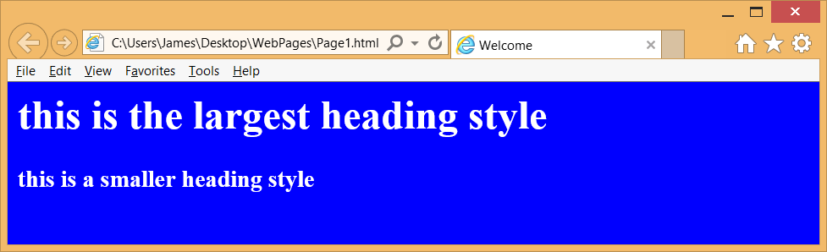

**STEP 7 Proceed to the Next Project**

Keep both Notepad and your browser open and continue modifying this project by following the instructions in the subsequent projects.

**Project Two Adding Special Effects to Your Page**

**Objective** To build a Web page using HTML tags.

***PROJECT DESCRIPTION***

This project continues form the prior project and reviews the basics of Web page design using basic HTML tags.

***Information about This Project***

A basic HTML tag and its functions are summarized below.

|  |  |  |
| --- | --- | --- |
| HTML **Tag** | type | **Purpose** |
| **<style>** | paired | applies styles to the Web page |

***Steps To Complete This Project***

**STEP 1**  **Open Notepad on your Computer**

If it is not already open, launch Notepad. If it is not already open, open the HTML document named **Page1.htm** that you created in the prior project.

**STEP 2 Add a Scrolling Message to Your Web Page**

In Notepad, locate the following HTML tag:

**</head>**

Directly above this tag, write the following statement.

**<style type = "text/css">**

**h1 { text-shadow: 5px 5px 5px #FF0000; }**

**</style>**

After you type the statement, save your Web page in Notepad.

**STEP 3 Load the Page in the Web Browser**

Leave Notepad open and return to Internet Explorer. If the page is already open in the browser, and press F5 to refresh the page in the browser. If the page is not open in the browser, open the page in Internet Explorer.

The page now has a text effect, as indicated in the snapshot given below.

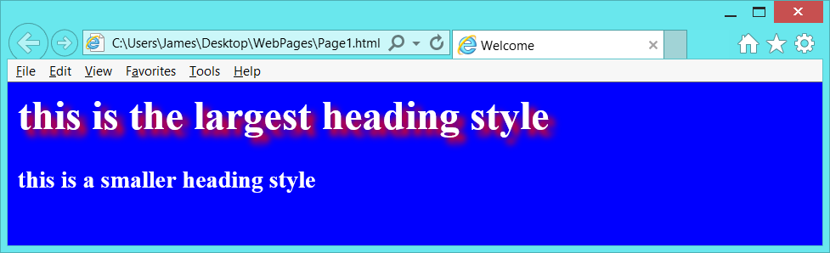

Next, modify your HTML Web page such that the **<h3>** tag also has a text effect, but with different pixel size and effects color than the **<h1>** tag.

**STEP 4 Proceed to the Next Project**

Keep both Notepad and your browser open and continue modifying this project by following the instructions in the subsequent projects.

**Project Three Adding Hyperlinks to Your Page**

**Objective** To build a Web page using HTML tags.

***PROJECT DESCRIPTION***

This project continues form the prior project and reviews the basics of Web page design using basic HTML tags.

***Information about This Project***

A basic HTML tag and its functions are summarized below.

|  |  |  |
| --- | --- | --- |
| HTML **Tag** | type | **Purpose** |
| **<a>** | paired | anchors text and navigates user to another page |

***Steps To Complete This Project***

**STEP 1**  **Open Notepad on your Computer**

If it is not already open, launch Notepad. If it is not already open, open the HTML document named **Page1.htm** that you created in the prior project.

**STEP 2 Add Link Color to Your Web Page**

In Notepad, locate the following HTML tag:

**<h3>this is a smaller heading style</h3>**

After the closing angle bracket > of the above tag, press enter and include the following line - break tag.

**<br />**

After you type this statement, save your Web page in Notepad.

**STEP 3 Add a Hyperlink to Your Web Page**

In Notepad, locate the following HTML tag:

**</body>**

Directly above this tag, write the following statement.

**<a href = "http://www.fye.com">music and movies</a>**

After you type the statement, save your Web page in Notepad.

**STEP 4 Load the Page in the Web Browserm,**

Leave Notepad open and return to Internet Explorer. If the page is already open in the browser, and press F5 to refresh the page in the browser. If the page is not open in the browser, open the page in Internet Explorer.

The page now has a visible hyperlink.

**STEP 5 Test the Hyperlink and Add another Link**

Within your Web page, click the hyperlink to test it. You should now be taken to the Web site **FYE.com** . View the site and click your browser’s Back

button to return to your Web page.

With your first hyperlink working, add another line - break after the above link and add a new hyperlink which links to the **ESPN.com** sports Web site.

**STEP 6 Proceed to the Next Project**

Keep both Notepad and your browser open and continue modifying this project by following the instructions in the subsequent projects.

**Project Four Adding an Image to Your Page**

**Objective** To build a Web page using HTML tags.

***PROJECT DESCRIPTION***

This project continues form the prior project and reviews the basics of Web page design using basic HTML tags.

***Information about This Project***

A basic HTML tag and its function are summarized below.

|  |  |  |
| --- | --- | --- |
| HTML **Tag** | type | **Purpose** |
| **<img>** | non - paired | holds an image |

***Steps To Complete This Project***

**STEP 1**  **Open Notepad on your Computer**

If it is not already open, launch Notepad. If it is not already open, open the HTML document named **Page1.htm** that you created in the prior project.

**STEP 2 Add an Image Tag to Your Web Page**

In Notepad, locate the following HTML tag:

**</body>**

Directly above this tag, write the following statements.

**<br />**

**<img src = "picture.wmf">**

After you type the statement, save your Web page in Notepad.

**STEP 3 Locate a Clip Art Image**

Open Windows Explorer on your computer. Locate a Clip Art image that you prefer. Clip Art images can be found by going to Program Files, Microsoft Office, Media and cagcat10 . Copy the image file into your **WebPages** folder on your **Desktop**. Rename the file as **picture** and retain the **wmf** file extension.

If necessary, you can also choose and download a GIF picture file by visiting the

following Web site: [**http://www.gifanimations.com**](http://www.gifanimations.com)

**STEP 4 Load the Page in the Web Browser**

Leave Notepad open and return to Internet Explorer. If the page is already open in the browser, and press F5 to refresh the page in the browser. If the page is not open ion the browser, open the page in Internet Explorer.

The page now shows your image.

**STEP 5 Modify the Project**

Modify your image tag by supplementing it with these attributes:

**alt** specifies an alternate text for an image

**height** specifies the height of an image, in pixels

**width** specifies the width of an image, in pixels

**STEP 6 Proceed to the Next Project**

Keep both Notepad and your browser open and continue modifying this project by following the instructions in the subsequent projects.

**Project Five Adding a Horizontal Rule and a Line Break to Your Page**

**Objective** To build a Web page using HTML tags.

***PROJECT DESCRIPTION***

This project continues from the prior project and reviews the basics of Web page design using basic HTML tags.

***Information about This Project***

A basic HTML tag and its function are summarized below.

|  |  |  |
| --- | --- | --- |
| HTML **Tag** | type | **Purpose** |
| **<hr />** | non - paired | horizontal line is created |

***Steps To Complete This Project***

**STEP 1**  **Open Notepad on your Computer**

If it is not already open, launch Notepad. If it is not already open, open the HTML document named **Page1.htm** that you created in the prior project.

**STEP 2 Add an Horizontal Reference to Your Web Page**

In Notepad, locate the following or similar HTML tag in your Web page:

**<img src = "picture.wmf">**

Directly above this tag, write the following statement.

**<hr width = "100%" align = "center">**

After you type the statement, save your Web page in Notepad.

**STEP 3 Load the Page in the Web Browser**

Leave Notepad open and return to Internet Explorer. If the page is already open in the browser, and press F5 to refresh the page in the browser. If the page is not open ion the browser, open the page in Internet Explorer.

The page now shows your horizontal rule or reference.

You can also try using newer CSS ( Cascading Style Sheets ) formats for the **<hr />** tag. One way is by incorporating this code into the **<style>** tag.

**hr**

**{**

**border: none;**

**background-color: #ccc;**

**color: #ccc;**

**height: 1px;**

**}**

**STEP 4 Proceed to the Next Project**

Keep both Notepad and your browser open and continue modifying this project by following the instructions in the subsequent projects.

**Project Six Adding a Paragraph of Text to Your Page**

**Objective** To build a Web page using HTML tags.

***PROJECT DESCRIPTION***

This project continues form the prior project and reviews the basics of Web page design using basic HTML tags.

***Information about This Project***

A basic HTML tag and its function are summarized below.

|  |  |  |
| --- | --- | --- |
| HTML **Tag** | type | **Purpose** |
| **<p>** | paired | adds a paragraph to your Web page |

***Steps To Complete This Project***

**STEP 1**  **Open Notepad on your Computer**

If it is not already open, launch Notepad. If it is not already open, open the HTML document named **Page1.htm** that you created in the prior project.

**STEP 2 Add a Paragraph of Text to Your Web Page**

In Notepad, locate the following HTML tag:

**</body>**

Directly above this tag, write the following statement.

Directly above this tag, write the following statements.

**<br />**

**<p>**

Directly below this **<p>** tag, write your name, course name and number.

Then close the **<p>** tag.

After you type the statements, save your Web page in Notepad.

**STEP 3 Load the Page in the Web Browser**

Leave Notepad open and return to Internet Explorer. If the page is already open in the browser, and press F5 to refresh the page in the browser. If the page is not open in the browser, open the page in Internet Explorer.

The page now shows your paragraph of text.

**STEP 4 Modify the Project**

Review your overall Web page and then perform the following modifications, embellishments and actions.

• Use two **<br />** tag to skip two lines within the **<body>** of your Web page.

• Using the **<u>** tag to write your favorite movie in underlined text.

• Using the **<b>** tag to write your favorite quote in bold text.

**Project Six**

• Using the **<i>** tag to write some plain text that indicates the date when your Web page was last updated.

• Using the **&copy;** character entity to include a © copyright symbol in your Web page. For example you can use:

© Copyright 2016 by Sammy Student

• Review the validation of your Web page by uploaded the page to the following site:

[**http://validator.w3.org/check**](http://validator.w3.org/check)

**STEP 5 Submit a Copy of Your Web Page**

With your Web page visible in the browser, save a copy and submit the file for credit.